University ERP
- How to run:
  - Requirements:
- Java JDK 11+
- MySQL Server 8.x
- MySQL Workbench / CLI
- JDBC Connector for MySQL
- An IDE: IntelliJ, Eclipse, NetBeans, etc.
  - External Dependencies Used:
- MariaDB JDBC Driver – database connectivity
- HikariCP – connection pooling
- BCrypt (jBCrypt) – password hashing
- Apache Commons Lang 3 – utility functions
- OpenCSV – CSV file export
- SLF4J (API + Simple Logger) – logging
- JUnit Jupiter (JUnit 5) – unit testing
  - Creating Databases:
- Open Terminal
- Navigate to the SQL file’s directory
- Before running the following command drop the databases by the name of auth_db and erp_db if you have
- Run: mysql -u root -p < SeededDat.sql
- Enter your MySQL password
- This restores both databases in one step.
  - Configure Database Connections:
- The project uses a app.properties file stored in the resourses package.
- Modify based on your local setup
- 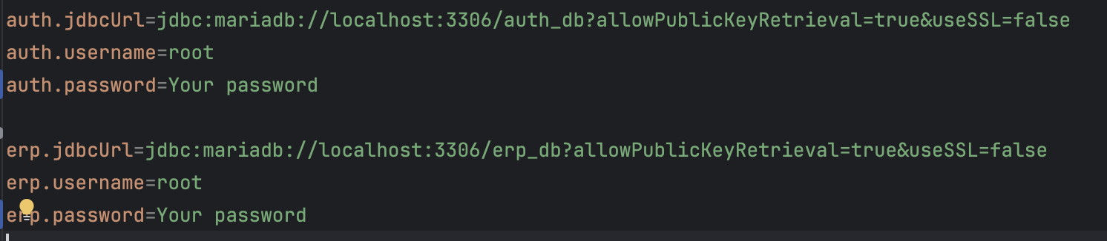
- Make sure:
  - The MySQL user exists
  - Reload pom.xml file to download the dependencies and the plugins

  - Build and run (Using IDE):
- Open the “project” folder in IntelliJ.
- Make sure the Project SDK is set to Java 17+.
- Ensure MySQL/MariaDB server is running.
- Build the project using pom.xml.
- Run the main file that launches the login window.
  - Build and run (Using cmd):
- Go to project root folder using cd command
- Run the following commands on cmd:
  - mvn clean compile
  - mvn exec:java -Dexec.mainClass="edu.univ.erp.Main"
  - javac -cp ".;lib/*" -d out src/main/java/edu/univ/erp/**/*.java
  - java -cp "out;lib/*" edu.univ.erp.Main
- Sample data:
  - Importing seed data:
- Open Terminal
- Navigate to the SQL backup file’s directory
- Run: mysql -u root -p < SeededDat.sql
- Enter your MySQL password
- This restores both databases in one step.
- Both the databases have seeded data in them
  - Seeded Passwords:
- Admin:
  - User: admin
  - Password: Admin@123
- Instructor:
  - User: inst1
  - Password: Inst@123
  - User: inst2
  - Password: Inst2@123
- Student:
  - User: stu1
  - Password: Stu@123
  - User: stu2
  - Password: Stu2@123
  - User: stu3
  - Password: Stu3@123

- Short Report
  - Folder Structure for the project

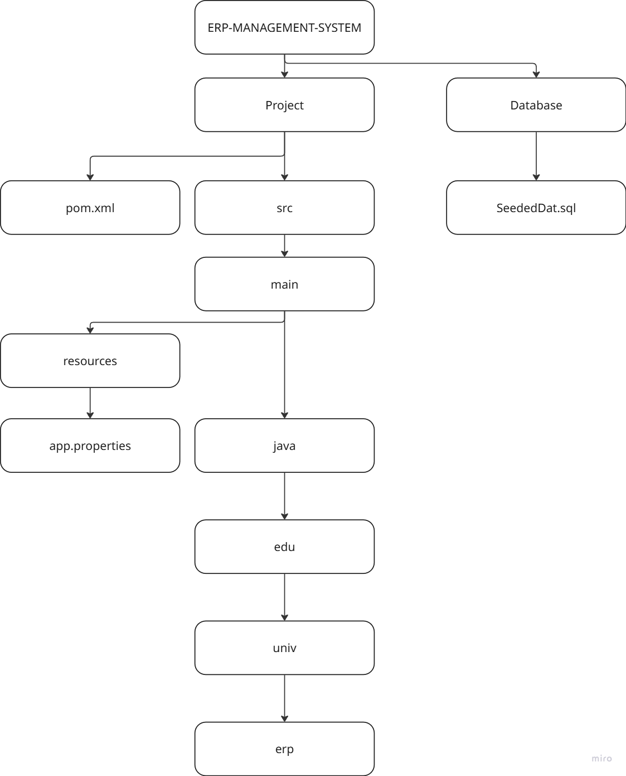
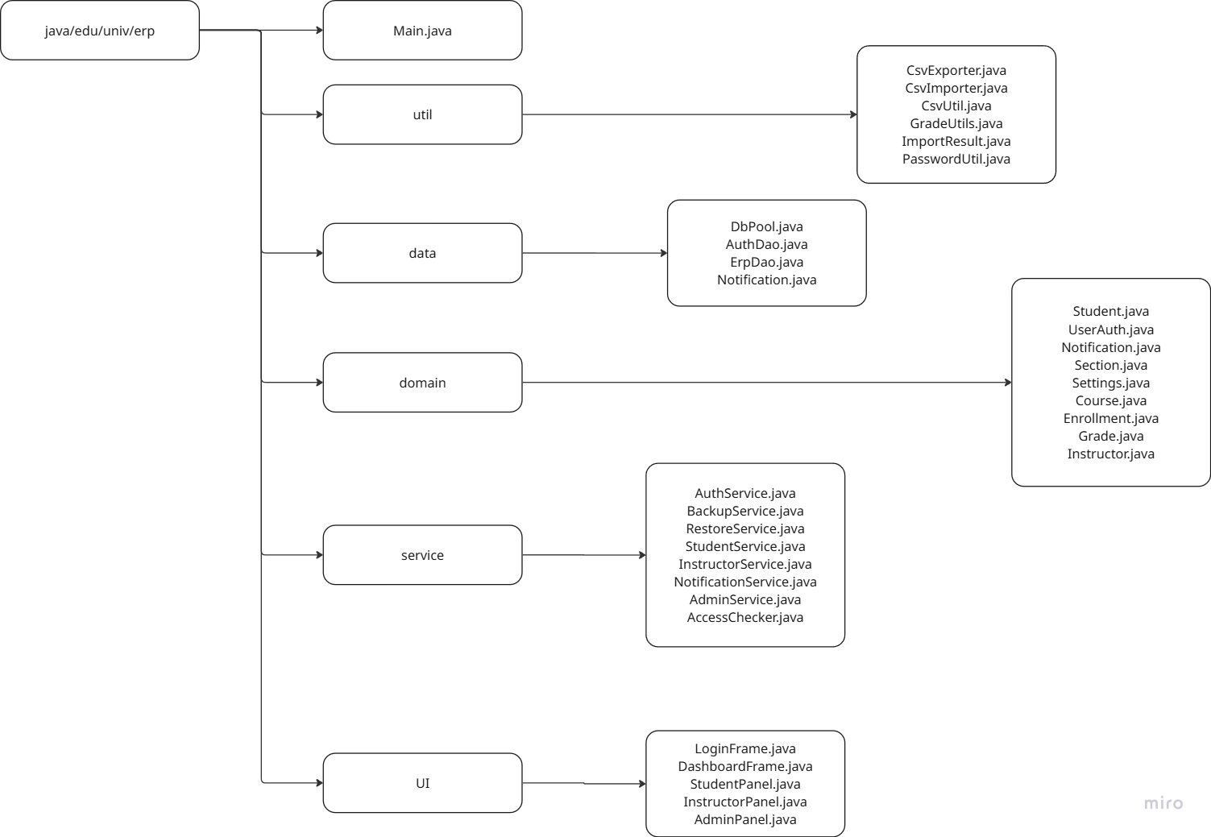
  - Student Panel:
- The student can enroll and drop sections from the button.
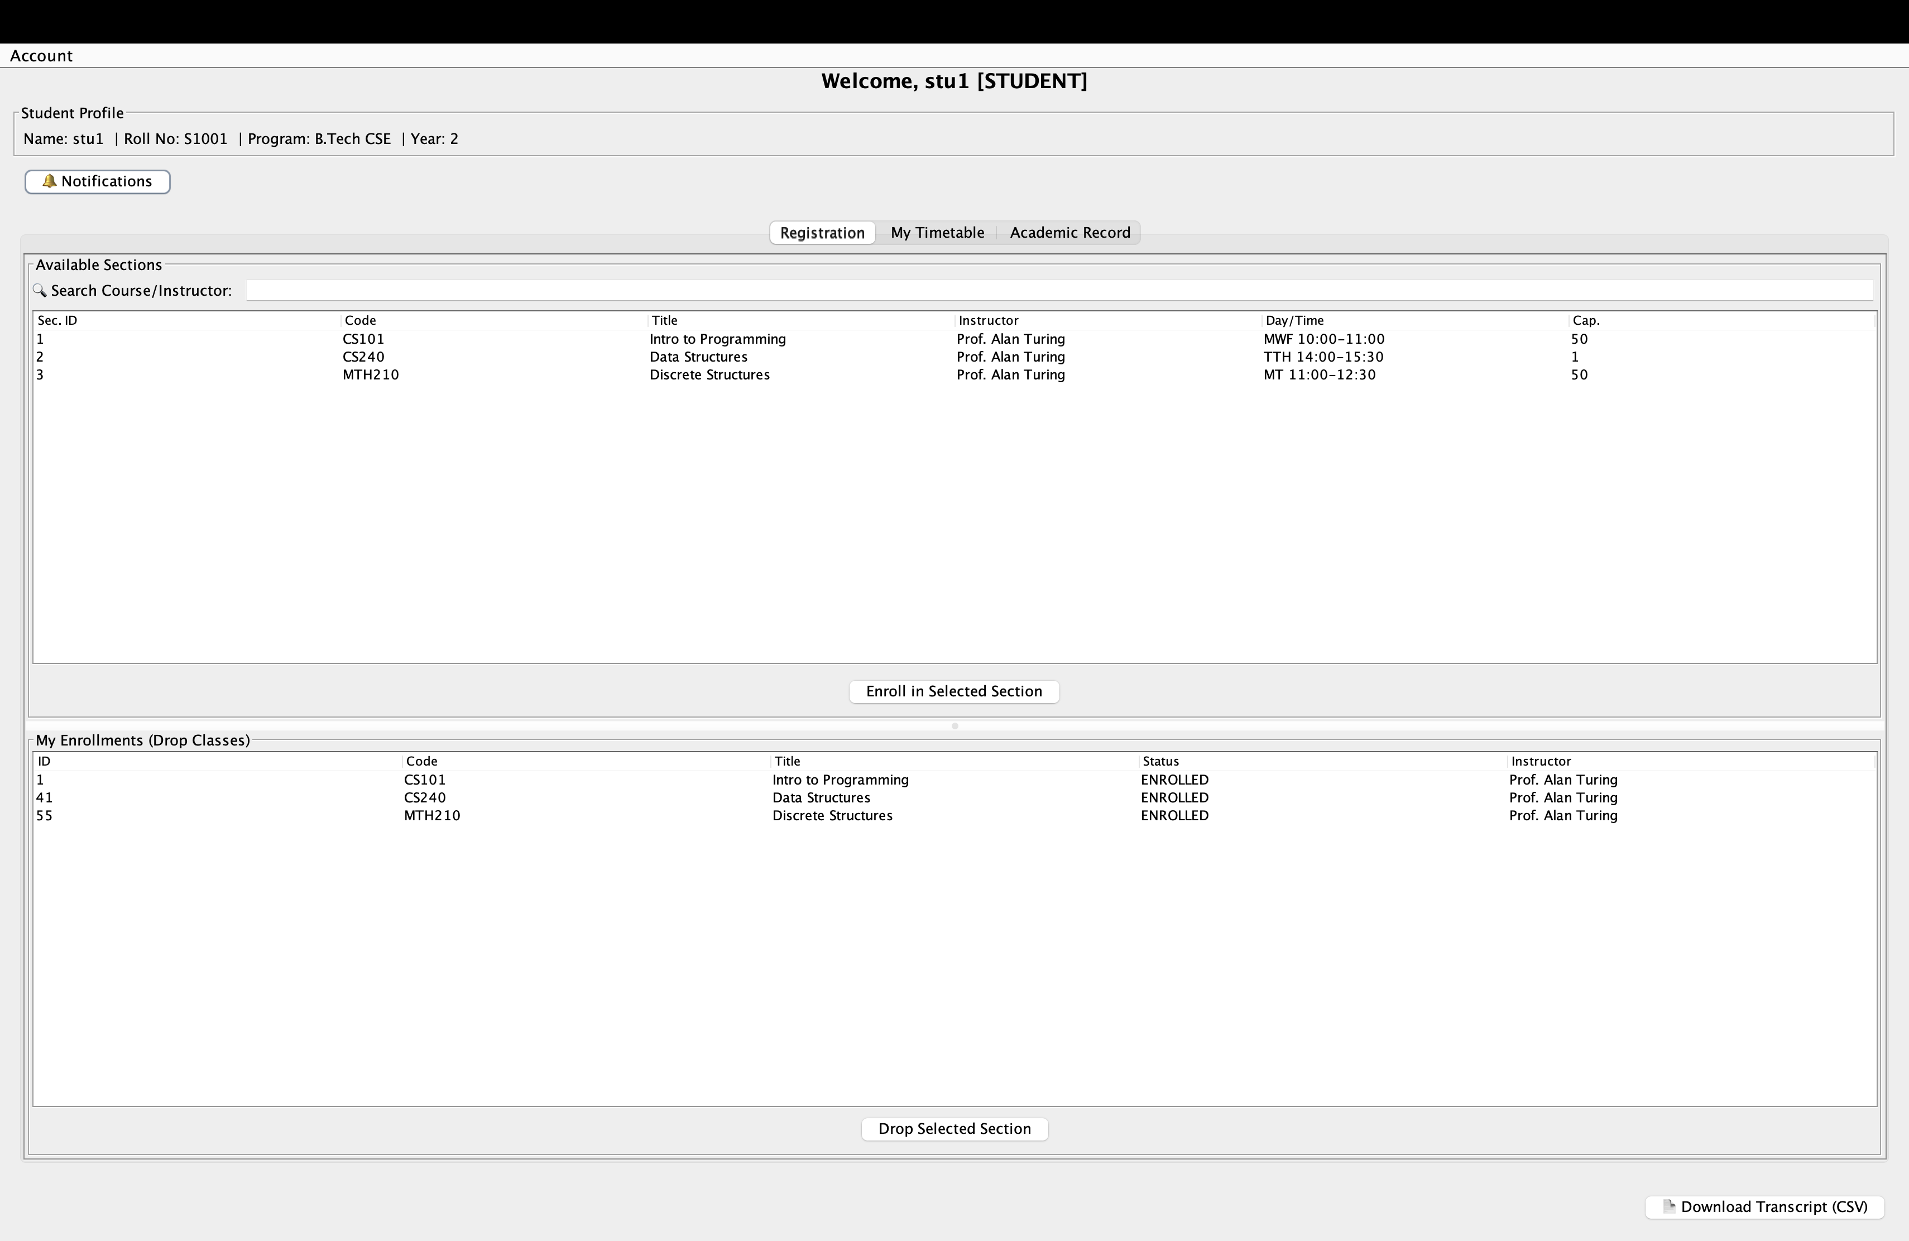
- 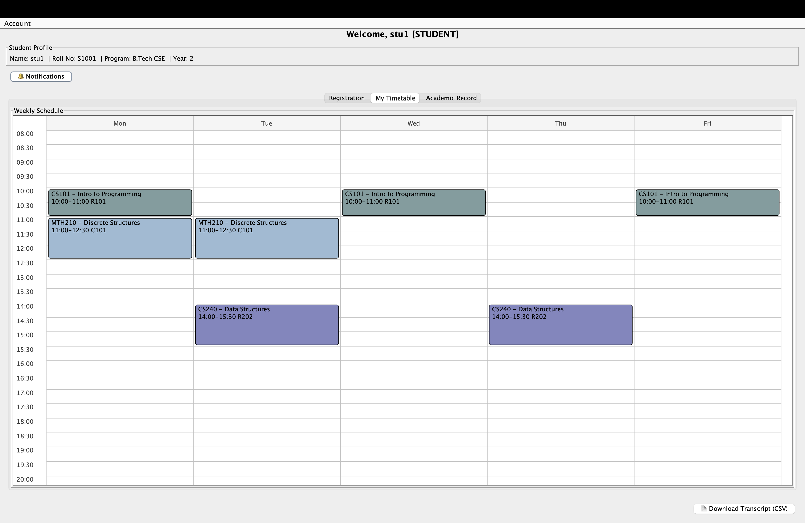
- The student can see the released grades here and can also download them.
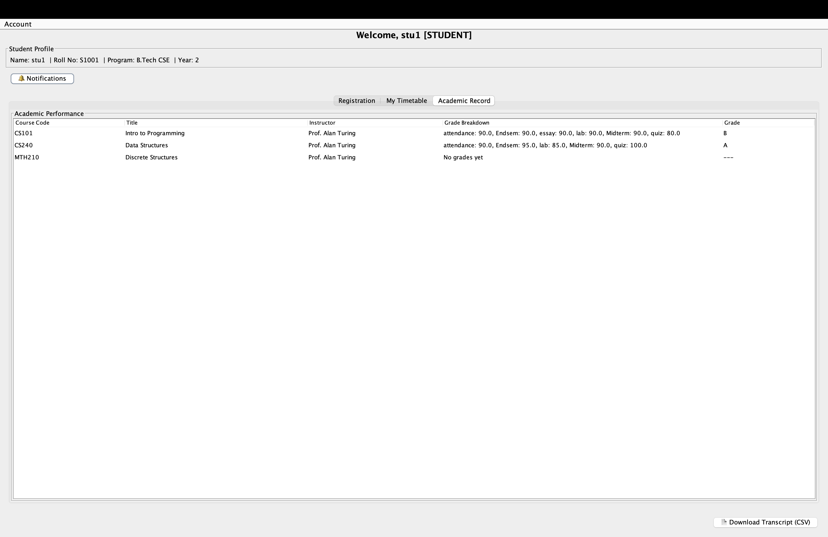

  - Instructor Panel
- The instructor can edit the grades of each student. He can add a new component, set weightage of each component as per his requirements, generate class statistics, import grades, release grades to the students, and download grades, and save them as csv file.
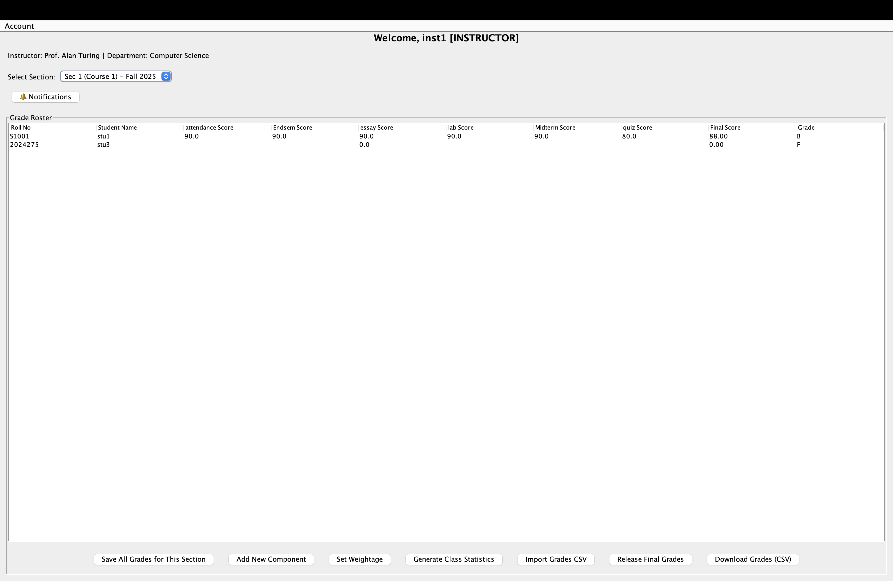

  - Admin Panel
- The admin can create a new user from here.
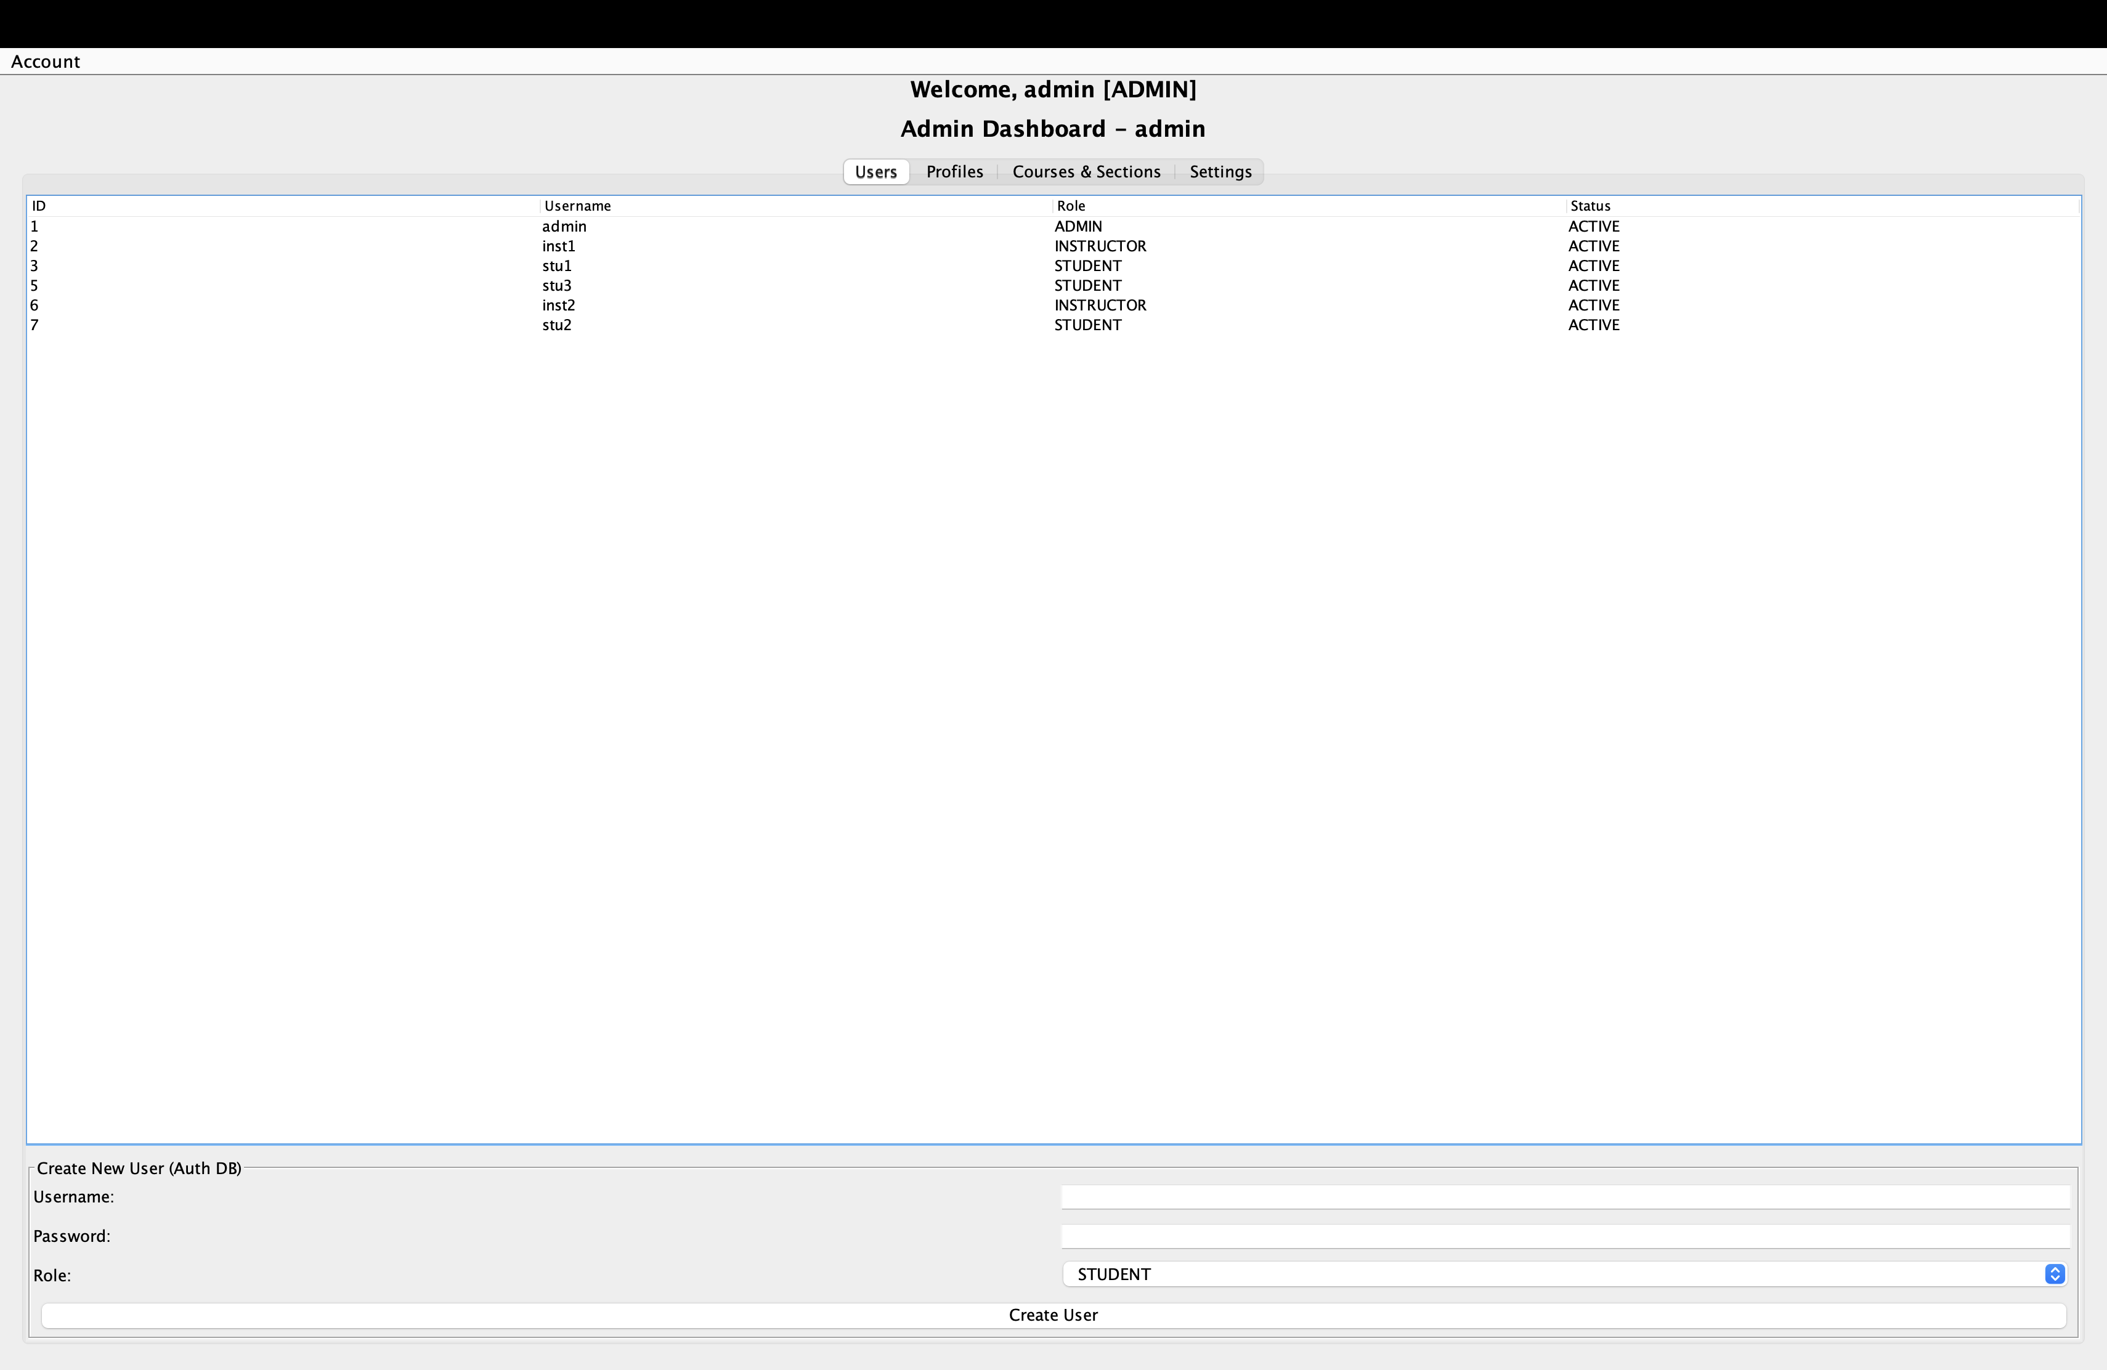
- The admin can create a new user profile from here.
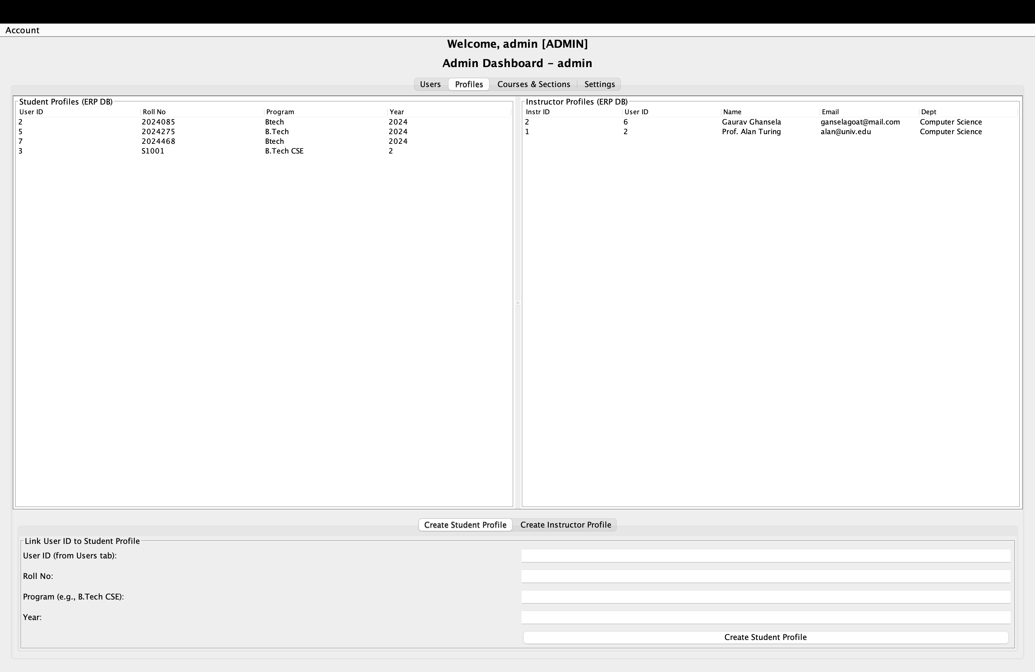
- The admin can toggle the maintenance mode, set deadline, backup, and restore database.
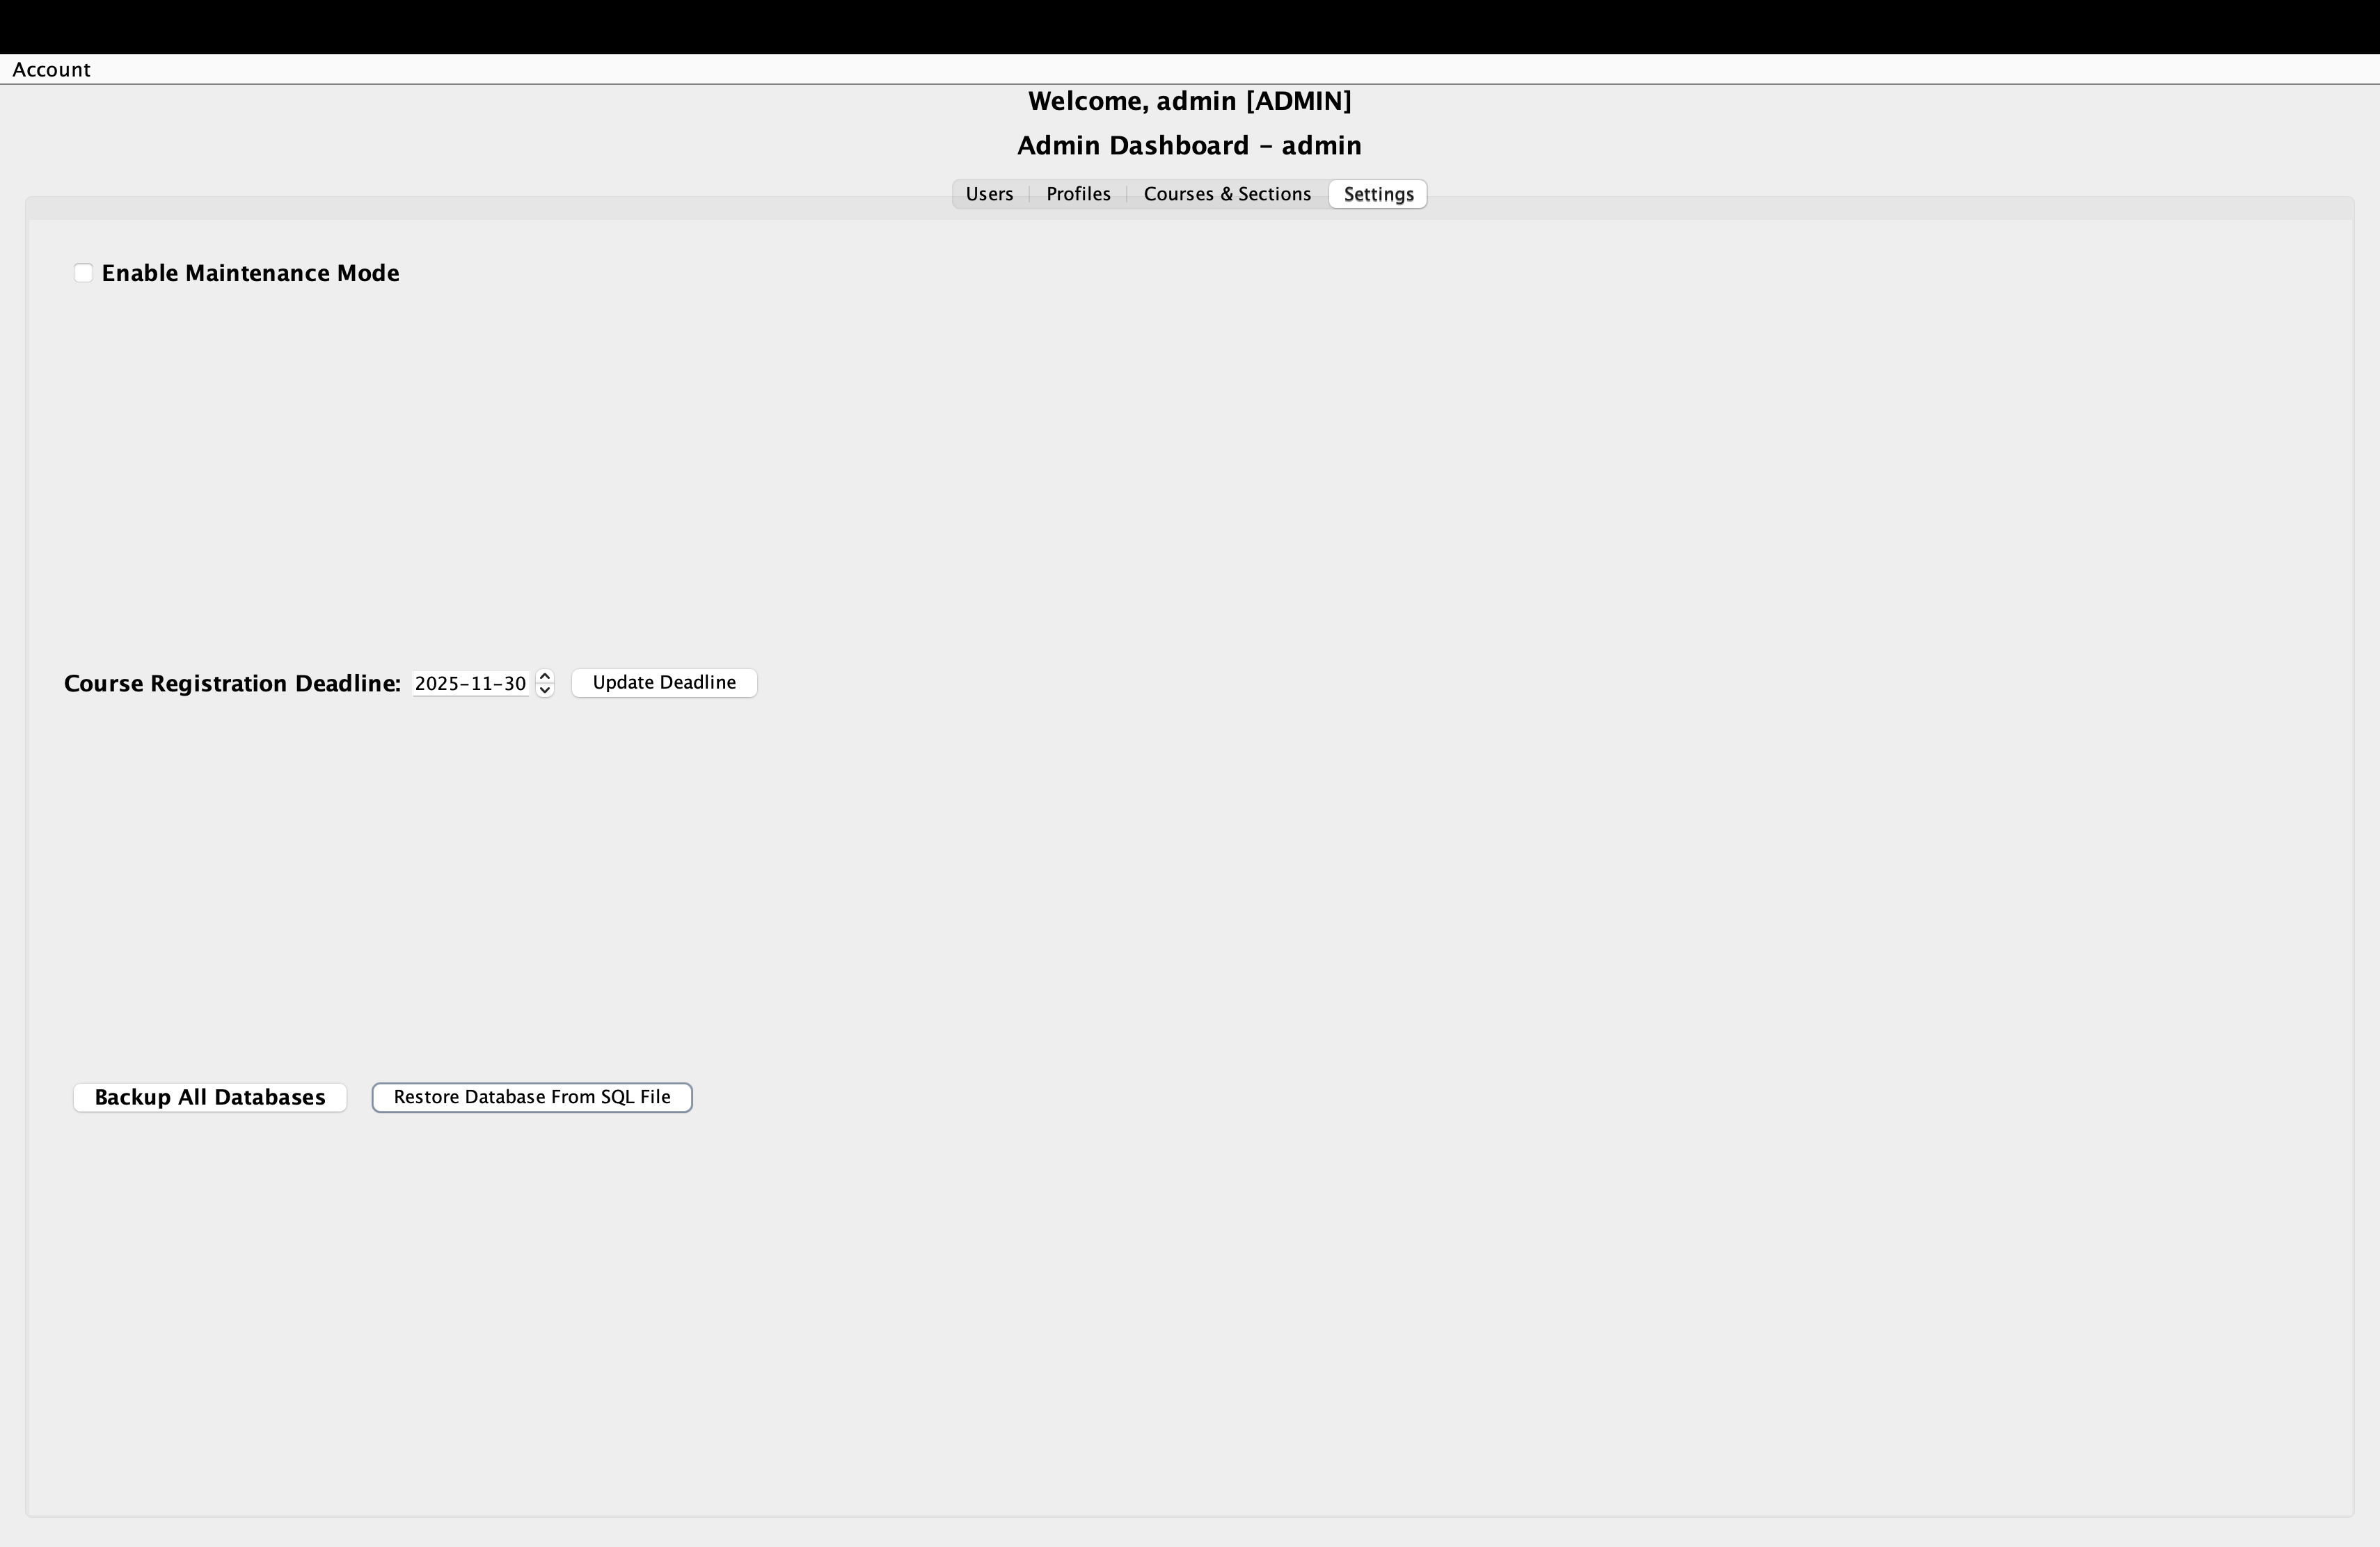
  - Final-Grade Weighting Rule:
- The instructor can set weightage for each component.

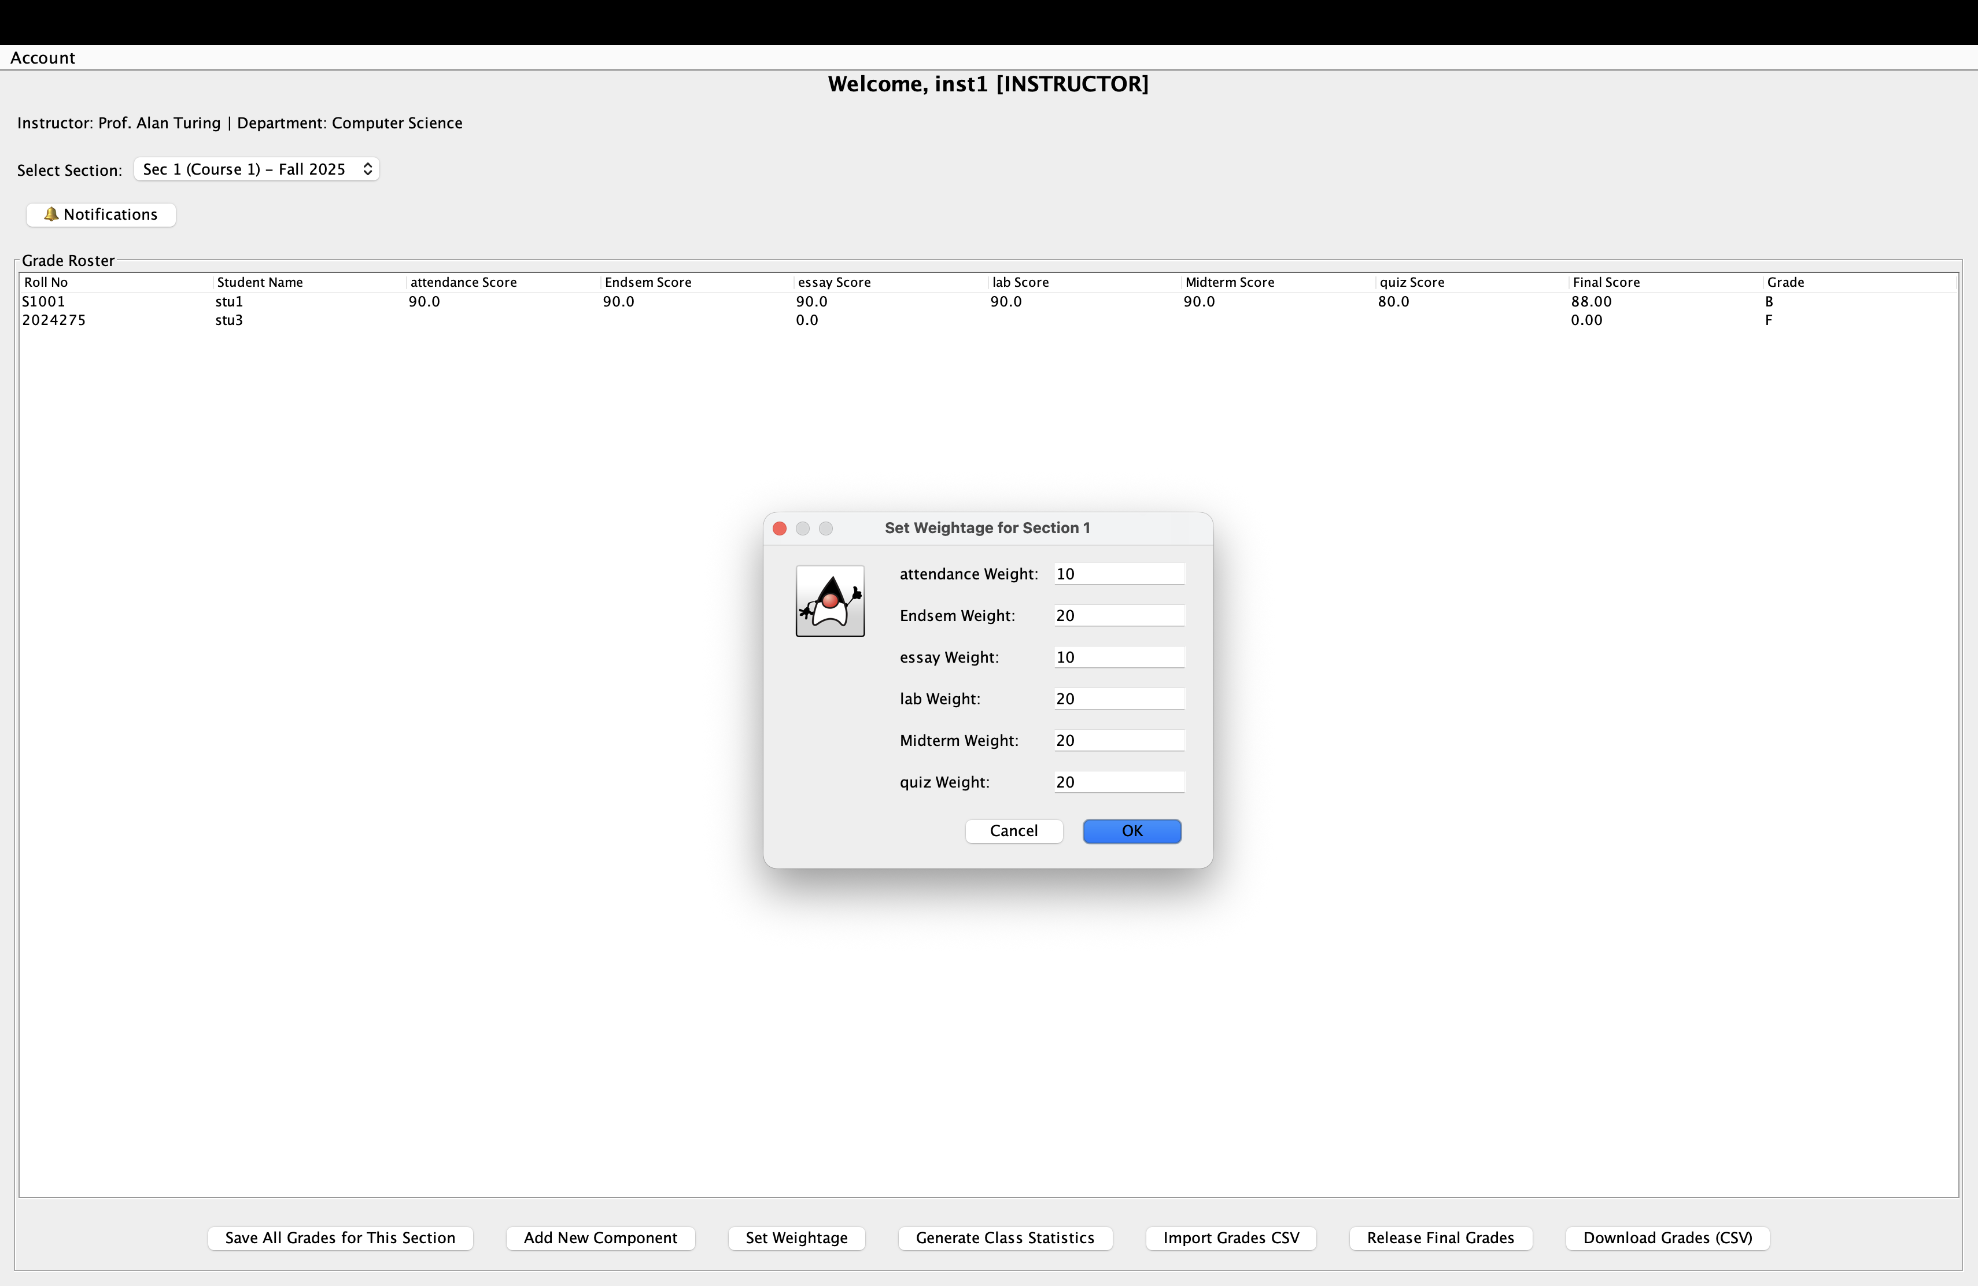
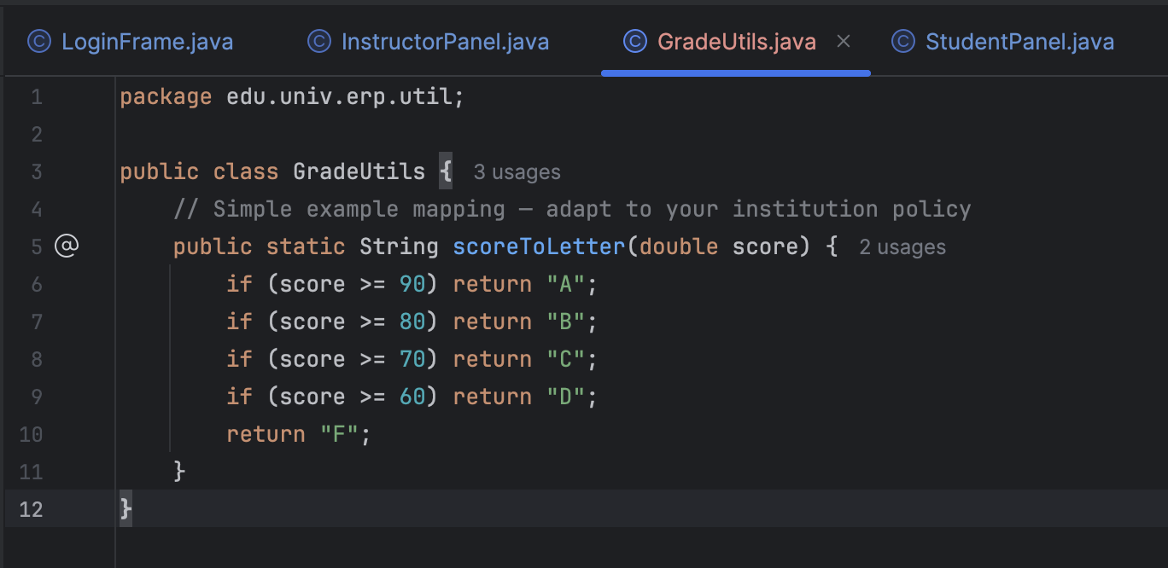

  - How roles & maintenance mode are enforced:
- 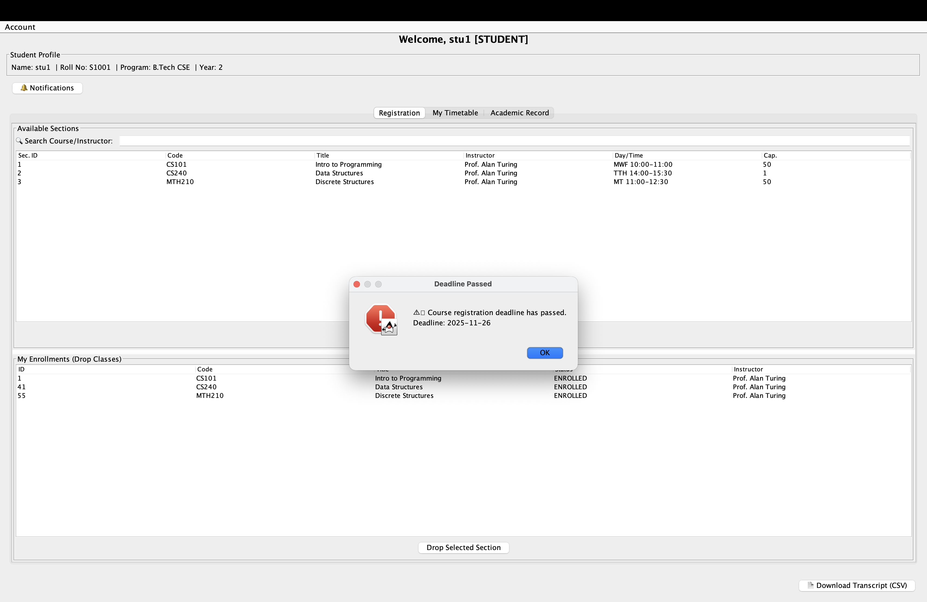
- The student can’t enroll or drop the section after the deadline has passed.
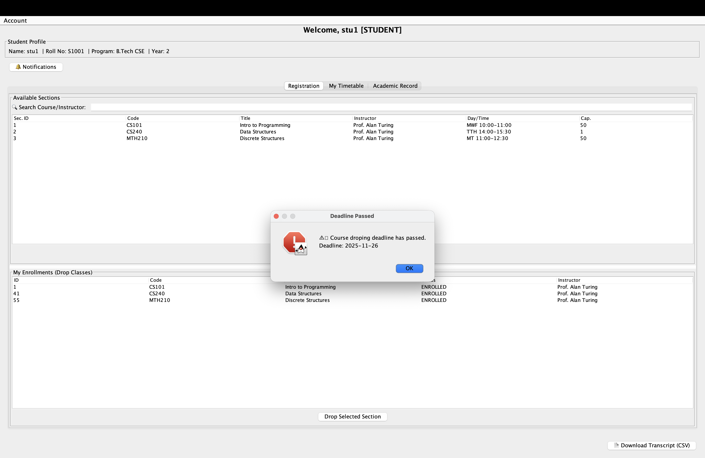
- The student and instructor can't make changes to the database when the maintainace mode is on.
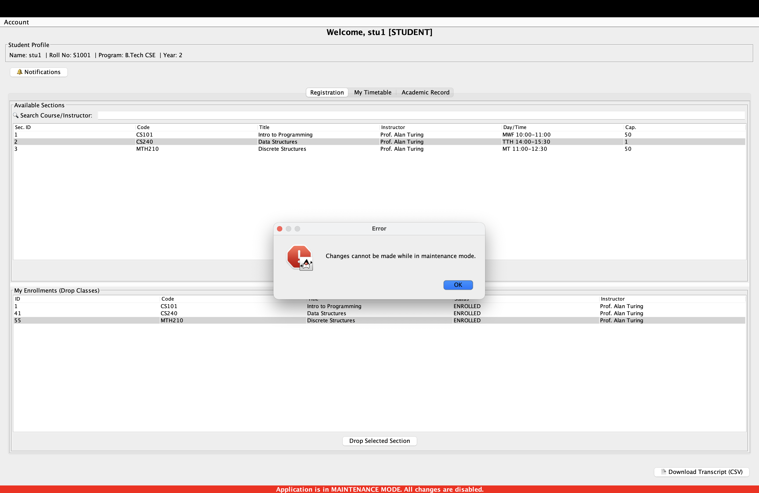
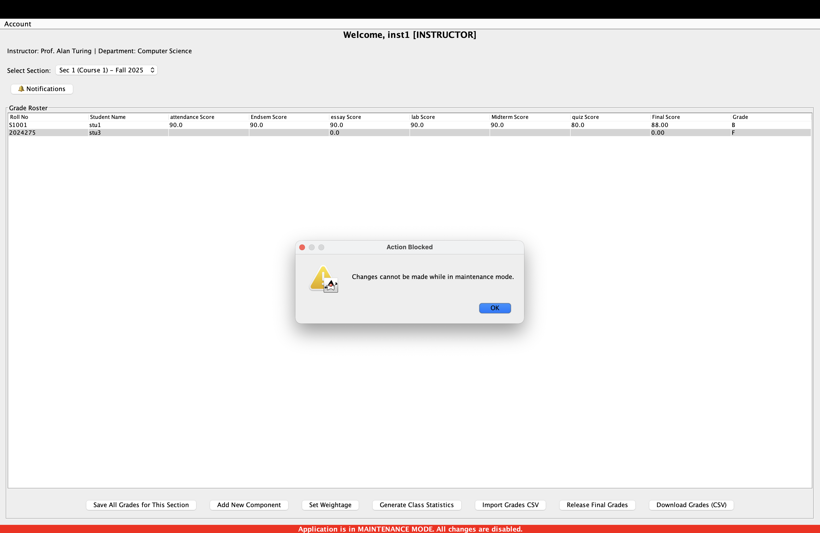

  - Database structure
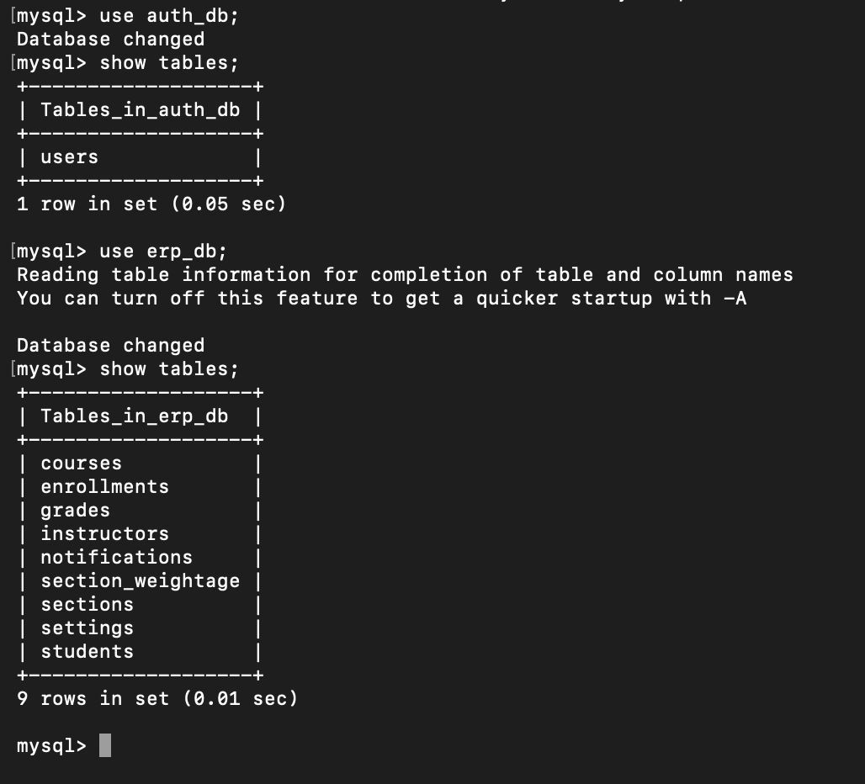

- Test Plan
  - Scope of testing:
- Included: Authentication, Student Module, Instructor Module, Admin Module, Maintenance Mode, Database Integration.
Not Included: UI refinement, performance testing.
  - Test Environment
- OS: Windows 10/MacOS
- Java: JDK 17
- Database: MySQL 8.x
Tools: IntelliJ, Workbench
  - Test Data
- Pre-seeded accounts
- Pre-seeded database from SeededDat.sql
- Sample sections
- CSV files.
  - Test Cases

Scenario | Test Steps | Result
Admin Login | Enter valid admin credentials | Dashboard loads with admin panel
Add new user | Go to Users → Add User → Fill form → Save | User created in Database; visible in table
Create student/instructor profile | After adding user → Create student/instructor profile for user → Fill form → Save | Successfully updated in database
Add course | Go to Courses → Add Course → Save | Course appears in course list
Add section | Go to Sections → Add Section → Save | Section stored in Database
Delete section (0 students enrolled) | Go to admin → Courses & Sections → Select a section to delete → Click on delete section | Section is deleted and database updated
Assign instructor | While adding section → Choose instructor → Save | instructor_id updated in Database
Toggle maintenance mode | Click “Enable Maintenance” | Maintenance ON; student/instructor restricted
Toggle maintenance mode OFF | Click “Disable Maintenance” | All users regain normal access
Update course deadline | Go to settings → change date in deadline → click on update | Course deadline updated in database
Backing up database | Go to settings → Backup databases → select path to save | File saved containing all information regarding database
Restoring database | Go to settings → Restore databases → select path to saved file | Database updated using the provided file

Scenario | Steps | Result
Instructor Login | Enter valid instructor credentials | Dashboard loads with instructor panel
View my sections | Login → My Sections | Only instructor’s assigned sections shown
Load roster | Select section | Roster table loads with roll, name, components
Enter component score | Edit cell → Save | Grade inserted/updated in Database
Add new component | Click “Add Component” → Enter name | New column appears; Database updated
Update weightage | Set new weightages → Save | section_weightage updated
Calculate final score | Enter scores → Save | Final grade computed correctly
Release grades | Click “Release Grades” | Grades visible to students; Database updated
Export CSV | Click “Download Grades (CSV)” | Dynamic CSV generated with components
Import CSV (Valid) | Import → Choose valid CSV | Grades updated; final grade recalculated
Import CSV (Student Missing) | Import CSV with invalid roll | Warning shown; row skipped; rest imported
Notifications | Click notification | Unread notifications displayed

Scenario | Steps | Result
Student login | Enter valid student credentials | Dashboard loads with student panel
View catalog | Click Registrations | List of all courses shown under available sections
Register section | Click Register → Confirm | Enrollment row added
Drop section | Click Drop → Confirm | enrollment removed
View timetable | Click “Timetable” | Timetable grid shown
View grades | Click “Academic Records” | Grades visible only if released
Download transcript CSV | Click “Download Transcript” | CSV downloaded with correct data
Notifications | Click notifications | Notifications shown

Scenario | Steps | Result
Instructor tries editing anything during maintenance | Maintenance ON from admin → Edit grade → Save | Error dialog: “Action blocked during maintenance mode.”
Student tries registering during maintenance | Maintenance ON from admin → Try to register | Blocked with warning
Admin override | Admin edits anything | Allowed

Scenario | Steps | Result
Export section roster | Click Export CSV from Instructor panel | CSV has dynamic columns & final grade
Import valid CSV | Choose valid CSV to import from Instructor panel | All scores updated in Database
Import CSV with missing student | Import CSV with unknown roll | Warning shown; only known rows imported
Import CSV with malformed score | Enter “ABCD” as score | That score ignored; rest imported

Scenario | Steps | Result
Student receives grades released | Instructor releases grades → Student checks notification | Notification visible
Student receives new section | Admin adds a new section → Student checks notification | Notification visible
Instructor receives section assigned | Admin assigns a section to instructor | Notification appears
Mark all read | Click “Mark All Read” | All notifications marked read

Scenario | Steps | Result
Change password success | Enter old password + new | Password updated
Wrong old password | Enter wrong old password | Error: Incorrect password

Scenario | Steps | Result
Section capacity is not negative or nonsensical. | Admin adds a section with negative capacity or characters instead of numbers | Error shown
Register/drop after the course deadline | Student tries to enroll or drop section after deadline | Error shown
Login with wrong password | Enter invalid credentials | “Invalid username/password”
Register for full section | Section capacity reached | Error shown
Add duplicate course code | Admin adds duplicate | Error shown
Add duplicate user | Admin adds duplicate | Error shown
Instructor enters text in numeric score | Enter “abc” | Doesn’t let the user type
Remove section with student enrolled in it | Go to admin → Courses & Sections → Select a section to delete → Click on delete section | Error shown

  - Execution Summary
- All of the above test cases pass without any flaws

